**SUM OF ODD NUMBERS**

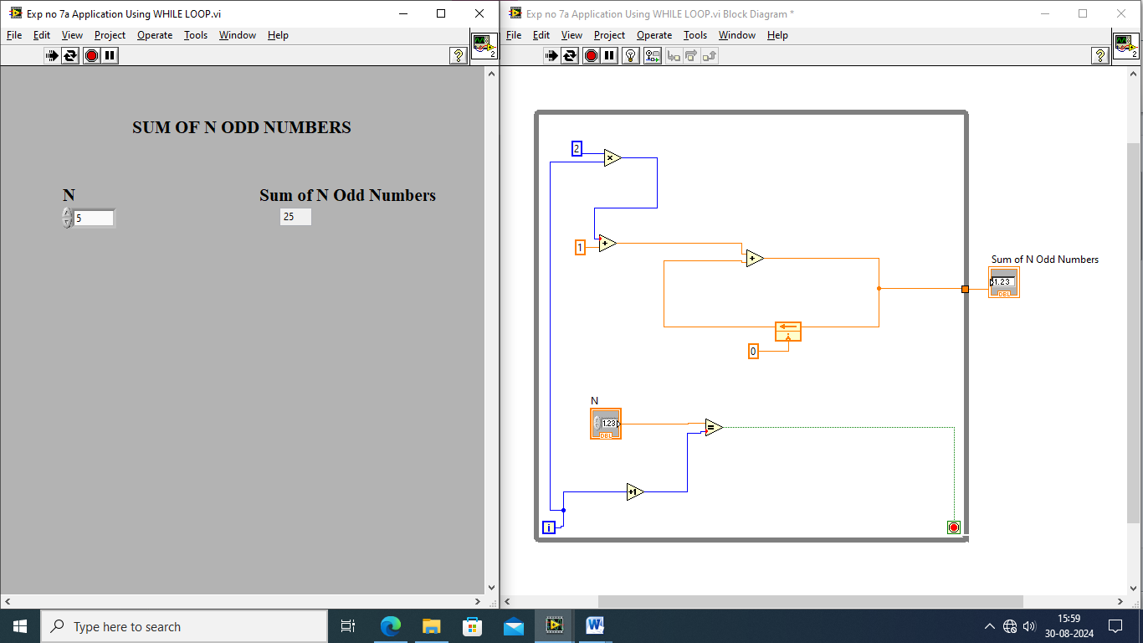

**SUM OF EVEN NUMBERS**

